CREATE JAVA APPLICATION

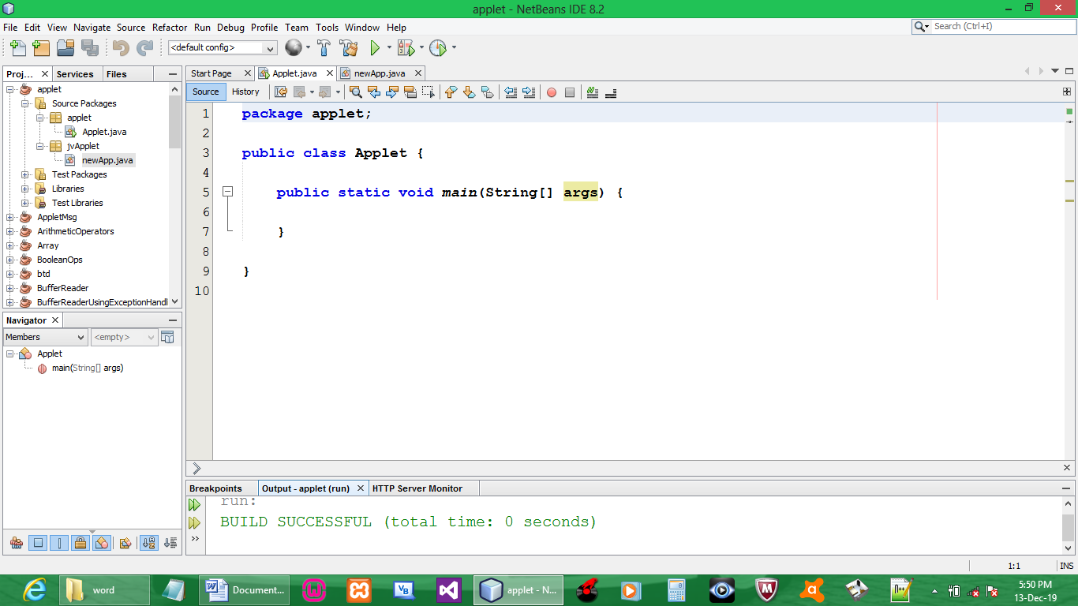

CREATE JAVA APPLET

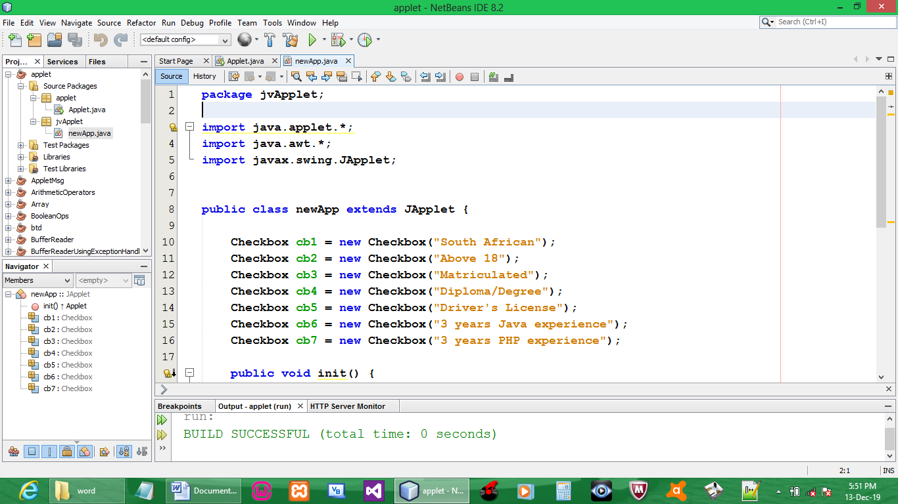

CODE:

package jvApplet;

import java.applet.*;
import java.awt.*;
import javax.swing.JApplet;

public class newApp extends JApplet {

Checkbox cb1 = new Checkbox("South African");
Checkbox cb2 = new Checkbox("Above 18");
Checkbox cb3 = new Checkbox("Matriculated");
Checkbox cb4 = new Checkbox("Diploma/Degree");
Checkbox cb5 = new Checkbox("Driver's License");
Checkbox cb6 = new Checkbox("3 years Java experience");
Checkbox cb7 = new Checkbox("3 years PHP experience");

public void init() {

add(cb1);
add(cb2);
add(cb3);
add(cb4);
add(cb5);
add(cb6);
add(cb7);

super.init();

}

}

OUTPUT:

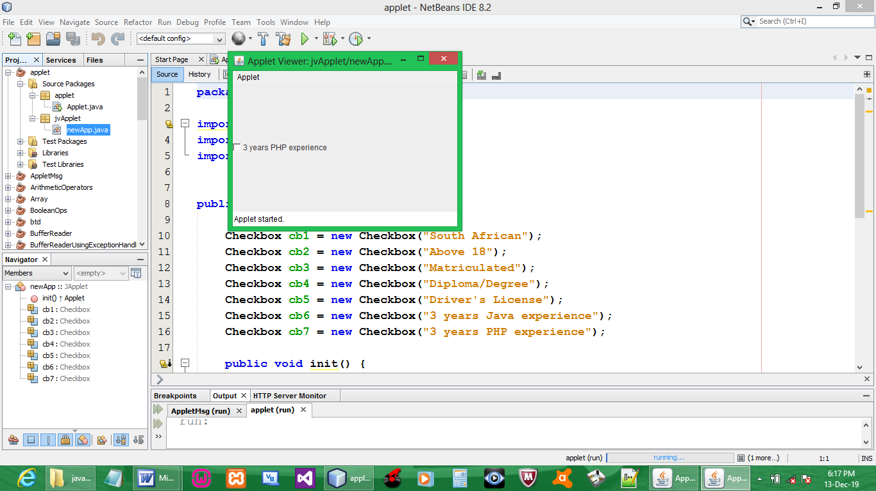

NB: majority of checkboxes don’t appear on the applet (FIX !!!)

